🧠 I. Introduction to Azure Data Factory
🔹 Key Concepts
- ADF is a cloud-native ETL/ELT tool for orchestrating data movement and transformation.
- Supports big data workloads, hybrid integration, and code-free pipelines.
- Works seamlessly with Synapse Analytics and Microsoft Fabric.
🧠 Real-Time Example
Migrate customer data from on-prem SQL Server to ADLS Gen2 using ADF pipelines.
✅ Best Practices
- Choose ELT for cloud-native transformations (e.g., using Spark).
- Use ADF as the central orchestrator across services.

🛠️ II. Setting Up the Azure Environment
🔹 Key Steps
- Create a free Azure account and navigate the Azure portal.
- Set up Resource Groups to organize services.
- Create Storage Accounts and choose between:
  - Blob Storage (flat structure)
  - Data Lake Gen2 (hierarchical folders)
🔐 Data Redundancy Options
Option | Description
LRS | Locally redundant
ZRS | Zone redundant
GRS | Geo redundant
GZRS | Geo-zone redundant

Redundancy options
✅ Short Notes: Azure Regions, Redundancy & Availability Zones

🌍 1. Azure Region — What & Why
- A geographical area containing multiple Azure datacenters.
- Examples: Central India, East US, West Europe.
- Used for deployment, latency optimization, and redundancy.
✅ Example
Deploy ADF + Databricks + Storage in Central India.
If the region fails, workloads can shift to South India (paired region).

🔁 2. Region Pairs
- Azure pairs regions for disaster recovery.
- Paired regions are far apart but connected with high-speed links.
- Examples:
  - Central India ↔ South India
  - West Europe ↔ North Europe
✅ Example
Storage in Central India automatically replicates to South India when using GRS.

🧱 3. Availability Zones (AZs)
- Physically separate datacenters inside the same region.
- Each zone has independent power, cooling, and networking.
- Usually 3 zones per region.
✅ Example
East US has Zone 1, Zone 2, Zone 3.
If Zone 1 fails, services in Zone 2 and Zone 3 continue running.

🏗️ 4. How Availability Zones Are Built
- Datacenters are kilometers apart for fault isolation.
- Each zone has:
  - Separate power grid
  - Separate cooling systems
  - Separate network paths
- Connected with ultra-low latency (<2 ms) fiber.
✅ Example
A fire in Zone 1 does not affect Zone 2 or Zone 3.

🧊 5. Azure Storage Redundancy Options

✅ LRS — Locally Redundant Storage
- 3 copies in one datacenter.
- Protects against hardware failure, not zone/region failure.
- Cheapest.
Example
Staging data in Central India stored only in one building.

✅ ZRS — Zone-Redundant Storage
- 3 copies across 3 Availability Zones in the same region.
- Protects against datacenter/zone failure.
- High availability.
Example
Customer uploads stored across Zone 1, 2, 3 in East US.
Zone 1 outage → data still available.

✅ GRS — Geo-Redundant Storage
- 6 copies total:
  - 3 in primary region (LRS)
  - 3 in paired region
- Protects against regional disasters.
- Secondary region is not readable.
Example
Data in Central India → replicated to South India automatically.

✅ RA-GRS — Read-Access Geo-Redundant Storage
- Same as GRS, plus read access to secondary region.
- Best for global read workloads.
Example
Primary in West Europe, secondary in North Europe.
Analytics team reads from secondary to reduce load.

🧩 6. When to Use What (Quick Guide)
Scenario | Best Option
Staging / temp data | ✅ LRS
Production workloads needing zone protection | ✅ ZRS
DR compliance / regional protection | ✅ GRS
Global read + DR | ✅ RA-GRS

🎯 7. Real-World Pipeline Example (ADF + Databricks + Storage)
✅ Deployment
- ADF in Zone 1
- Databricks in Zone 2
- Storage (ZRS) across Zone 1, 2, 3
✅ Failure Scenario
Zone 1 outage →
- ADF restarts in Zone 2/3
- Databricks unaffected
- Storage still available
Your pipeline continues running.

Real-Time Example
Create a Data Lake container /raw/sales/ with GZRS for high availability.
✅ Best Practices
- Use Event Grid registration for blob-triggered pipelines.
- Enable hierarchical namespace for Data Lake folders.

🧩 III. Foundational ADF Concepts
🔹 Core Components
- Linked Services: Define connections (e.g., SQL DB, Blob Storage).
- Datasets: Point to actual data (e.g., table, file).
- ADF Studio Tabs:
  - Home: Quick access
  - Author: Build pipelines
  - Monitor: View runs
  - Manage: Linked services, triggers, IRs
🧠 Real-Time Example
Create a linked service to Azure SQL DB and a dataset pointing to dbo.Customers.

🔄 IV. ADF Activities & Real-Time Scenarios
🔹 Key Activities
Activity | Purpose | Example
Copy Activity | Move data | Copy CSVs from /raw/ to /curated/
Get Metadata | Read folder/file info | List files in /raw/sales/
For Each | Loop through items | Process each file from metadata
If Condition | Apply logic | Copy only files starting with fact_
Set Variable | Store values | Save file name or run ID
Delete Activity | Clean up | Remove processed files
Execute Pipeline | Modular design | Trigger child pipeline for transformation

🔁 V. Data Flow Transformations (Code-Free)
🔹 Transformations
Transformation | Purpose | Example
Select | Choose columns | Keep CustomerID, Region
Filter | Row-level filtering | Region = 'APAC'
Conditional Split | Branch logic | Split by Region
Derived Column | Add/modify columns | coalesce(CustomerName, 'N/A')
Aggregate | Grouping | Sum of SalesAmount by Region
Alter Rows | DML operations | Mark rows for insert/update/delete
🧠 Real-Time Example
Cleanse and enrich sales data using Data Flow with Spark backend.

⏰ VI. Triggers for Pipeline Automation

🔹 Trigger Types
Trigger | Description | Example
Schedule | Run at intervals | Daily at 6 AM
Tumbling Window | Time-based with state | Process hourly batches
Storage Event | Blob event-based | Trigger when file is dropped in /incoming/

Here’s a crisp, interview-ready cheat sheet on Triggers in Azure Data Factory (ADF) — with types, examples, and differences.

✅ ADF Triggers – Notes
🔹 What is a Trigger?
- A trigger in ADF is a unit that starts pipeline execution automatically based on a defined condition.
- Instead of manually running pipelines, triggers help automate workflows.

🔹 Types of Triggers in ADF

1. Schedule Trigger
- Runs pipelines at a specific time or recurring schedule.
- Example: Run every day at 6 AM.
{
"type": "ScheduleTrigger",
"recurrence": "0 6 * * *"
}
- Use case: Daily ETL jobs, hourly ingestion, weekly reports.

2. Tumbling Window Trigger
- Runs pipelines in fixed-size, contiguous time intervals (windows).
- Each window is non-overlapping and can capture data slices.
- Supports dependency chaining (one window depends on another).
- Example: Run every 1 hour, process data for that hour.
{
"type": "TumblingWindowTrigger",
"interval": "01:00:00"
}
- Use case: Incremental loads, hourly batch processing, time-series data.

3. Event-Based Trigger
- Fires pipeline when a specific event occurs in storage (Blob Storage or ADLS).
- Example: When a new file is uploaded to ADLS container.
{
"type": "BlobEventTrigger",
"scope": "/subscriptions/.../storageAccounts/.../containers/input",
"events": ["Microsoft.Storage.BlobCreated"]
}
- Use case: Real-time ingestion, file-driven workflows.

🔹 Differences Among Triggers
Trigger Type | When It Runs | Key Feature | Example Use Case
Schedule | At fixed times | Simple recurrence | Daily batch load
Tumbling Window | Fixed, contiguous intervals | Dependency chaining, backfill support | Hourly incremental ETL
Event-Based | On file events | Real-time, reactive | Trigger pipeline when file arrives

🔹 Interview-Ready Summary
“ADF supports three trigger types: Schedule (time-based), Tumbling Window (fixed intervals with dependency chaining), and Event-Based (reactive to file events). Schedule is best for recurring jobs, Tumbling Window for incremental time-slice processing, and Event-Based for real-time ingestion when files land in storage.”

🧠 VII. Advanced Concepts & Best Practices
🔹 Key Topics
- Build end-to-end production pipelines with modular design.
- Apply data validation using If Condition, Data Flow, and Set Variable.
- Use Monitor tab for debugging and troubleshooting.
- Always publish changes to make pipelines executable.
- Consider data governance:
  - RBAC
  - Managed identities
  - Naming conventions
  - Audit logging
🧠 Real-Time Example
Validate schema, transform data, and log results in /logs/validation/.
✅ Comparison
Tool | Use Case
Data Flows | Code-free transformation
PySpark | Custom logic, advanced processing
Power Query | Lightweight transformation in Power BI

FORMATDATETIME()
In Azure Data Factory (ADF), the formatDateTime() function is used to format a date/time value into a specific string format. It's commonly used in expressions within pipelines, especially when working with dynamic content like filenames, folder paths, or timestamps.

🔧 Syntax
formatDateTime(&lt;timestamp&gt;, &lt;format&gt;)
- <timestamp>: The date/time value you want to format. It can be a system variable like @utcNow() or a column value.
- <format>: A string that defines the desired output format using .NET-style date/time format specifiers.

📅 Common Format Examples
Format String | Output Example | Description
yyyy-MM-dd | 2025-09-16 | Year-Month-Day
yyyyMMddHHmmss | 20250916194025 | Compact timestamp
MM/dd/yyyy | 09/16/2025 | US-style date
dd-MM-yyyy HH:mm | 16-09-2025 19:40 | Day-Month-Year with time
HH:mm:ss | 19:40:25 | Time only

✅ Example Usage in ADF
@formatDateTime(utcNow(), 'yyyy-MM-dd')
This returns the current UTC date in YYYY-MM-DD format.

🧠 Use Cases
- Naming output files with timestamps.
- Partitioning data by date.
- Logging and auditing pipeline runs.
- Dynamic folder paths in datasets or linked services.

Lookup Activity:
In Azure Data Factory (ADF), the Lookup activity is used to retrieve data from a source—typically a database or file—and make it available for use in subsequent activities within a pipeline.

🔍 Purpose of Lookup Activity
- Fetch a single row or dataset from a source.
- Use the retrieved data as parameters, conditions, or input for other activities like ForEach, If Condition, or Set Variable.

🧱 Key Components
- Source Dataset
  - Can be SQL, Azure Blob, REST API, etc.
  - You define the dataset and query or file path.
- First Row Only
  - If enabled, only the first row is returned.
  - Useful when you need a single value (e.g., a config setting or ID).
- Output
  - The result is stored in activity('LookupActivityName').output.
  - You can access:
    - value: array of rows (if First Row Only is false)
    - firstRow: single row (if First Row Only is true)

✅ Example Use Case
Suppose you want to get the latest file name from a metadata table:
SELECT TOP 1 FileName FROM FileMetadata ORDER BY CreatedDate DESC
Then use that filename in a Copy activity to pull the actual file.

🧠 Common Scenarios
- Parameterizing file names or paths
- Driving ForEach loops with a list of items
- Conditional logic based on values from a database
- Fetching configuration values from a control table

📌 Tips
- If you're expecting multiple rows, disable "First row only".
- Combine with Set Variable or If Condition for dynamic workflows.
- Use debug mode to inspect the output structure.

Get Metadata
✅ What GetMetadata CAN Retrieve
File-Level
- size → file size in bytes
- lastModified → last modified timestamp
- itemName → file name
- exists → true/false
- contentMD5 → MD5 hash (limited support)
Folder-Level
- childItems → list of files/folders (non-recursive)
- folderName
- exists
Dataset-Level
- structure → schema for structured files (CSV, Parquet)
- columnCount
- rowCount → only for databases, not ADLS files

❌ What GetMetadata CANNOT Retrieve
- File content (no preview, no sample rows)
- ACLs, permissions, RBAC, POSIX attributes
- Owner, created time, or security properties
- Recursive folder structure (only one level)
- Metadata for wildcard paths (*.csv)
- Row count for ADLS files
- Metadata for multiple files at once (unless looped)

✅ One-Line Interview Summary
“GetMetadata retrieves basic file/folder metadata like size, lastModified, exists, childItems, and schema, but it cannot read content, permissions, owner details, or recursive folder structures, and it doesn’t work with wildcards.”
Here’s a clear, structured, interview-ready explanation of the Set Variable activity in Azure Data Factory, along with a practical example you can use in real projects or onboarding documentation.

Set Variable Activity
The Set Variable activity in Azure Data Factory is used to assign a value to a pipeline variable at runtime.
It is commonly used for dynamic file names, counters, flags, paths, dates, and conditional logic inside pipelines.

✅ Why Do We Use Set Variable?
- To store values during pipeline execution
- To build dynamic file paths
- To store results from activities (e.g., Lookup, GetMetadata)
- To maintain counters inside loops
- To control branching logic
- To pass values into subsequent activities

✅ Types of Variables in ADF
Type | Description
String | Store text values (file names, paths, dates)
Boolean | True/false flags
Array | Store lists (file names, IDs, etc.)

✅ Example Scenario: Process Only Today’s File
Goal:
Pick today’s file from ADLS → Sales_2024-01-10.csv
Steps:
1. Create a pipeline variable
Name: todayFileName
Type: String
Default: empty

2. Use Set Variable activity
Expression:
concat('Sales_', formatDateTime(utcNow(), 'yyyy-MM-dd'), '.csv')
This sets the variable to something like:
Sales_2024-01-10.csv

3. Use the variable in Copy Activity
In the dataset file path:
@pipeline().variables.todayFileName
✅ Now your pipeline dynamically picks today’s file.

✅ Another Example: Using Set Variable inside ForEach
Scenario:
Iterate through files and store the current file name.
Inside ForEach → Set Variable
@item().name
This allows you to:
- Log the file name
- Pass it to Copy Activity
- Use it in If Condition
- Build dynamic sink paths

✅ Example: Increment a Counter
Variable:
fileCount → type: String or Int (via expression)
Set Variable Expression:
@string(add(int(variables('fileCount')), 1))
This increments the counter during each loop iteration.

✅ Interview-Ready Summary
“Set Variable activity is used to assign or update pipeline variables at runtime. It helps build dynamic file paths, store values from activities, control logic inside loops, and pass dynamic values to downstream activities. For example, you can use Set Variable to store today’s file name or to capture each file name inside a ForEach loop.”
Here’s a clean, structured, interview-ready explanation of Delete Activity and Execute Pipeline Activity in Azure Data Factory — with simple examples you can use in real projects or onboarding notes.

Delete Activity in ADF
🔹 What it does
The Delete Activity is used to delete files or folders from a storage location such as:
- ADLS Gen2
- Azure Blob Storage
- File System
- SFTP/FTP
It is commonly used for cleanup, archival, and retention policies.

🔹 Key Features
- Delete single file, multiple files, or entire folders
- Supports wildcards (e.g., *.csv)
- Can delete recursively
- Can delete based on last modified date (e.g., older than 30 days)

✅ Example Scenario
Goal: Delete all .csv files older than 7 days from a folder.
Steps:
- Create a dataset pointing to the folder:
/raw/sales/
- Add Delete Activity.
- Configure:
  - Wildcard: *.csv
  - Recursive: True
  - Last Modified:
    - Operator: Older than
    - Value: 7 days
✅ Result: All CSV files older than 7 days are automatically deleted.

Execute Pipeline Activity in ADF
🔹 What it does
The Execute Pipeline activity is used to call another pipeline from within a pipeline.
It helps you:
- Break large workflows into modular pipelines
- Reuse pipelines (e.g., a common ingestion pipeline)
- Pass parameters to child pipelines
- Maintain clean, manageable architecture

🔹 Why it’s useful
- Encourages reusability
- Reduces duplication
- Makes pipelines easier to maintain
- Supports parameter passing (dynamic execution)

✅ Example Scenario
Goal: A master pipeline triggers two child pipelines.
Pipelines:
- MasterPipeline
- IngestSalesPipeline
- TransformSalesPipeline
Steps:
- In MasterPipeline, add Execute Pipeline activity.
- Select IngestSalesPipeline.
- Add another Execute Pipeline activity.
- Select TransformSalesPipeline.
- Pass parameters if needed:
- {
- "fileName": "Sales_2024_01_10.csv"
- }
✅ Result:
Master pipeline → runs ingestion → then transformation → all orchestrated cleanly.

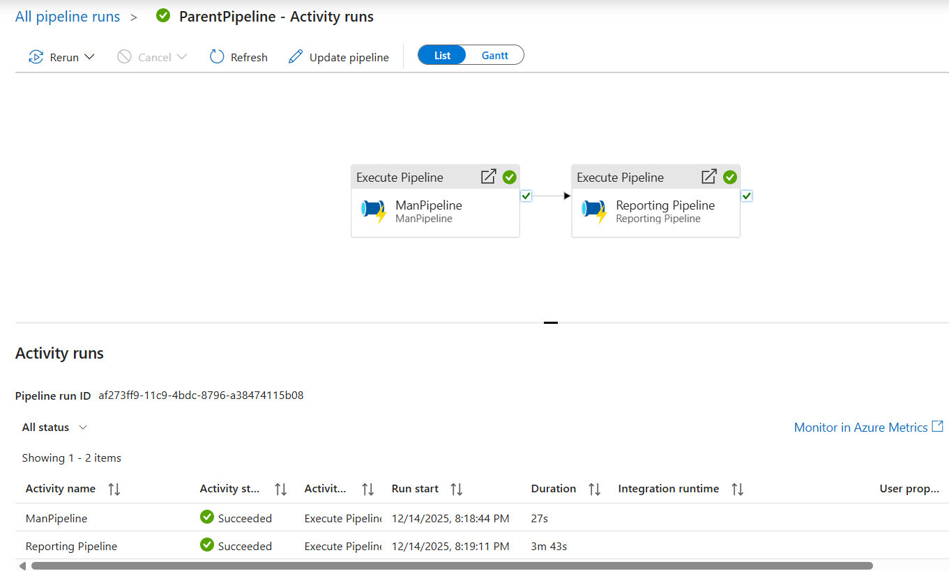

Example Project 1:
Copies all the files from github folder to ADLS
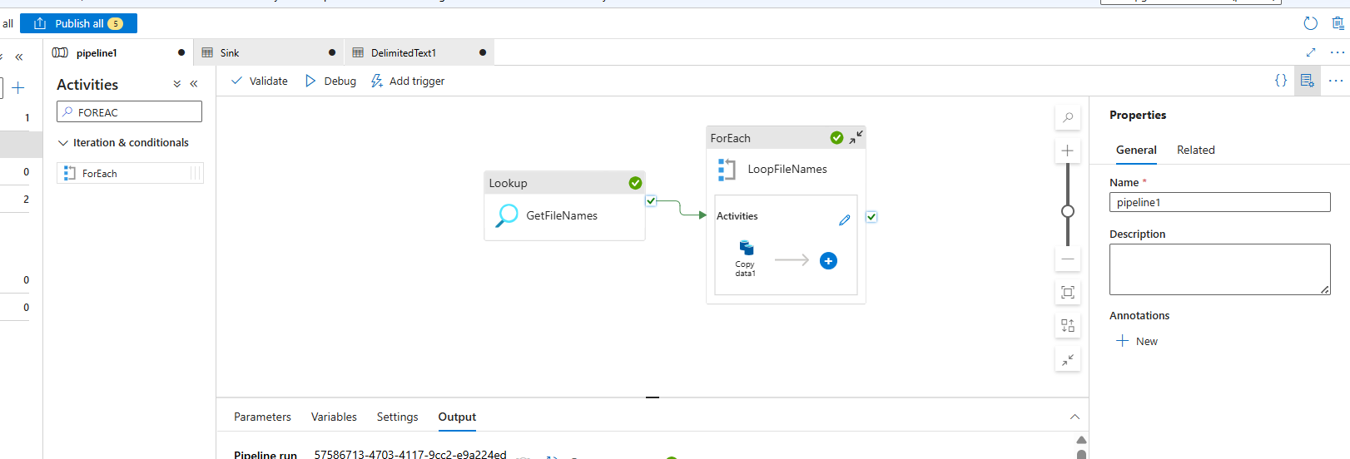

✅ ADF + GitHub API – Short Notes & Lessons Learned
🟦 1. Dataset Format Matters
- GitHub API returns JSON, not CSV.
- Always use a JSON dataset for Lookup.
- Use Array of Objects when GitHub returns a list.
✅ Wrong: DelimitedText
✅ Right: JSON (Array of Objects)

🟦 2. Lookup Output Must Be an Array
Your ForEach must loop over:
@activity('LookupGitFiles').output.value
If value is null → ForEach breaks → Error 2010.

🟦 3. item() Works ONLY Inside ForEach
ADF rules:
✅ Allowed:
Copy Activity → Source → Relative URL (inside ForEach)
❌ Not allowed:
- Dataset
- Linked Service
- Pipeline parameters
- Outside ForEach
If used outside →
'item' is not a recognized function

🟦 4. Never Pass Full URL When Base URL Exists
If your dataset has:
Base URL = https://raw.githubusercontent.com
Then your parameter must contain only the path, not the full URL.
Otherwise ADF produces:
https://raw.githubusercontent.comhttps://raw.githubusercontent.com/...
✅ Fix: Strip domain using replace()
@replace(item().download_url, 'https://raw.githubusercontent.com', '')

🟦 5. Use Dataset Parameters for Dynamic URLs
This avoids all item() errors.
Dataset:
- Parameter: FilePath
- Relative URL: @dataset().FilePath
Copy Activity:
@replace(item().download_url, 'https://raw.githubusercontent.com', '')

🟦 6. GitHub Folder Structure Is Optional
You do not need to recreate GitHub’s folder hierarchy in ADLS.
✅ Recommended:
Sink folder: source/RawFiles/
File name: @item().name

🟦 7. Required Header for GitHub API
Always add:
User-Agent: AzureDataFactory
Without this, GitHub rejects the request.
Output format of Lookup:
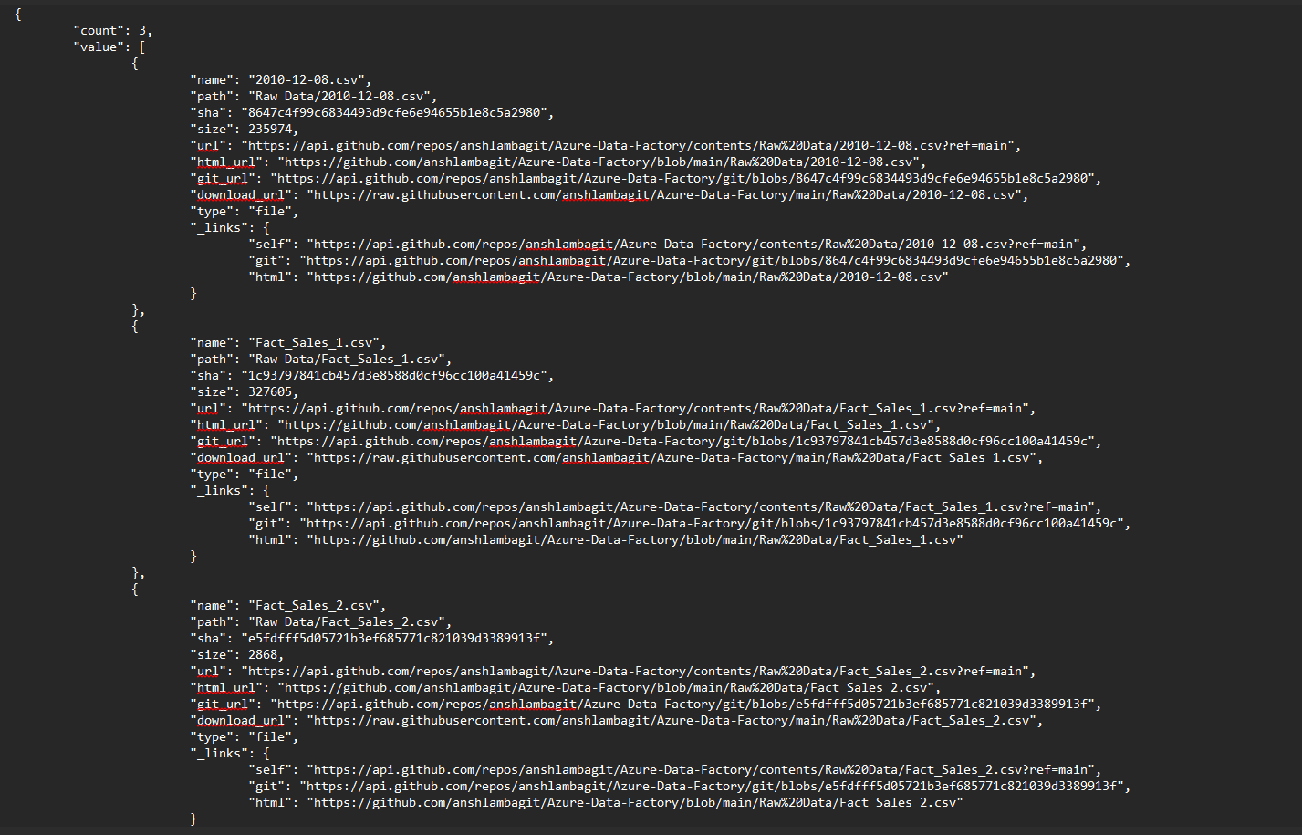

Example Project 2:
- Moved files from the source container to the Reporting container — only those whose names start with "Fact_Sales".
- Used GetMetadata to retrieve file names from ADLS.
- Iterated through the list using a ForEach activity.
- Inside ForEach, added an If Condition:
- @startswith(item().name, 'Fact_Sales')
- When the condition was true, executed a Copy Activity to move the file.
- After the copy succeeded, performed required data transformations on Fact_Sales_1.csv using Data Flow.
Overall Pipeline:
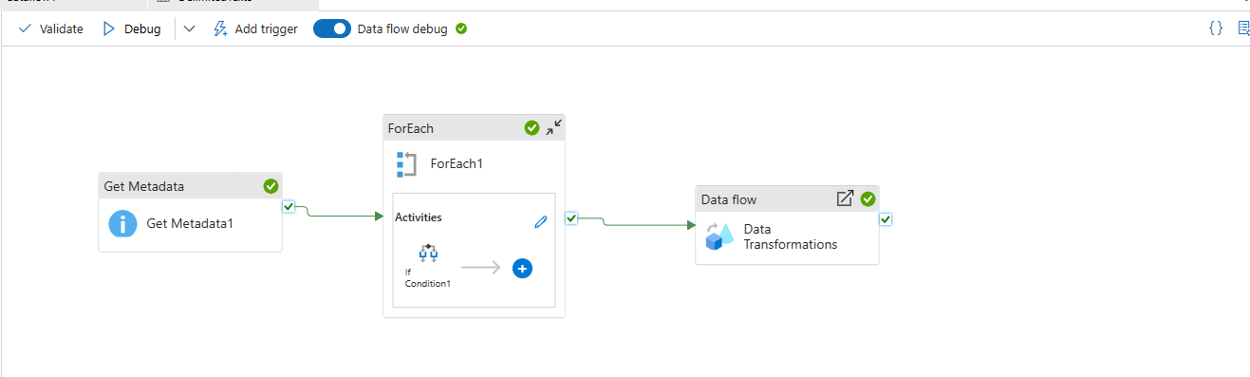
Inner of DataFlow:
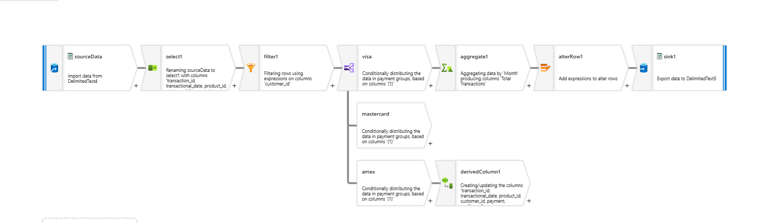

Here’s a clear, beginner-friendly, Data Flow–specific explanation of toString() — the function you actually use in Mapping Data Flows to format dates, numbers, and other values.

✅ ADF Data Flow: toString() Function Explained
toString() converts any value (date, timestamp, integer, decimal, boolean) into a string.
It is also used to format dates using patterns like yyyy, MM, MMM, MMMM, etc.

✅ Common Use Cases
✅ 1. Convert Date to Month Name
toString(dateCol, 'MMMM')
Output:
January, February, March, etc.
✅ 3. Convert Date to Any Format
toString(dateCol, 'yyyy-MM-dd')

✅ If your column is a string date
Convert it first:
toString(toDate(dateCol), 'MMMM')

✅ Supported Date Format Patterns
Pattern | Meaning | Example
yyyy | Year | 2024
MM | Month number | 03
MMM | Short month | Mar
MMMM | Full month | March
dd | Day | 15
HH:mm:ss | Time | 14:30:00

✅ Quick Summary (Interview-Ready)
toString() in ADF Data Flows converts values to strings and is also used to format dates. For example, toString(dateCol, 'MMMM') returns the full month name.

